Day 1: Spelling

Use spelling words to complete the boxes.
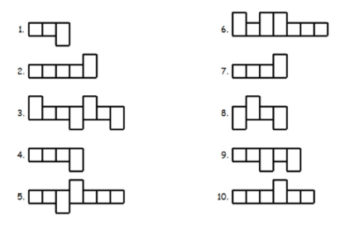
Write the spelling words in ABC order.
explain 1. ____________________ root 1. ____________________
meadow 2. ____________________ balloon 2. ____________________
display 3. ____________________ way 3. ____________________
away 4. ____________________ reach 4. ____________________

Day 2

Add the correct comparative ending ( -er or –est) to the word in ( ) to complete each sentence.

*Remember your spelling rules.

1. Is your dog (big) ___________________________ than my dog?
2. Moon Lake is the (close) _________________________ park to us.
3. That is the (chubby) ___________________________ dog I’ve seen.
4. That is the (pretty) ___________________________ tree on the lot.
5. The black cat is (heavy) ___________________________ than our cat.

Day 3
Circle the verbs in the sentences below. Underline the adverbs.
- She walked slowly across the classroom.
- The baby crawled quickly around the room.
Circle the preposition. Underline the prepositional phrase.
- I ate lunch with my family.
- She is sitting by her friend.
Day 4
Match the vocabulary word to its definition.
_____ invented a. to buy
_____ money b. the costs
_____ prices c. related to the value, monetary value
_____ purchase d. an orderly plan
_____ record e. a report of something that happens
_____ system f. created for the first time
_____ value g. worth or importance
_____worth h. dollars and cents

Write the vocabulary words in ABC order.
invented 1. ________________ record 1. ________________
money 2. ________________ system 2. ________________
prices 3. ________________ value 3. ________________
purchase 4. ________________ worth 4. ________________

